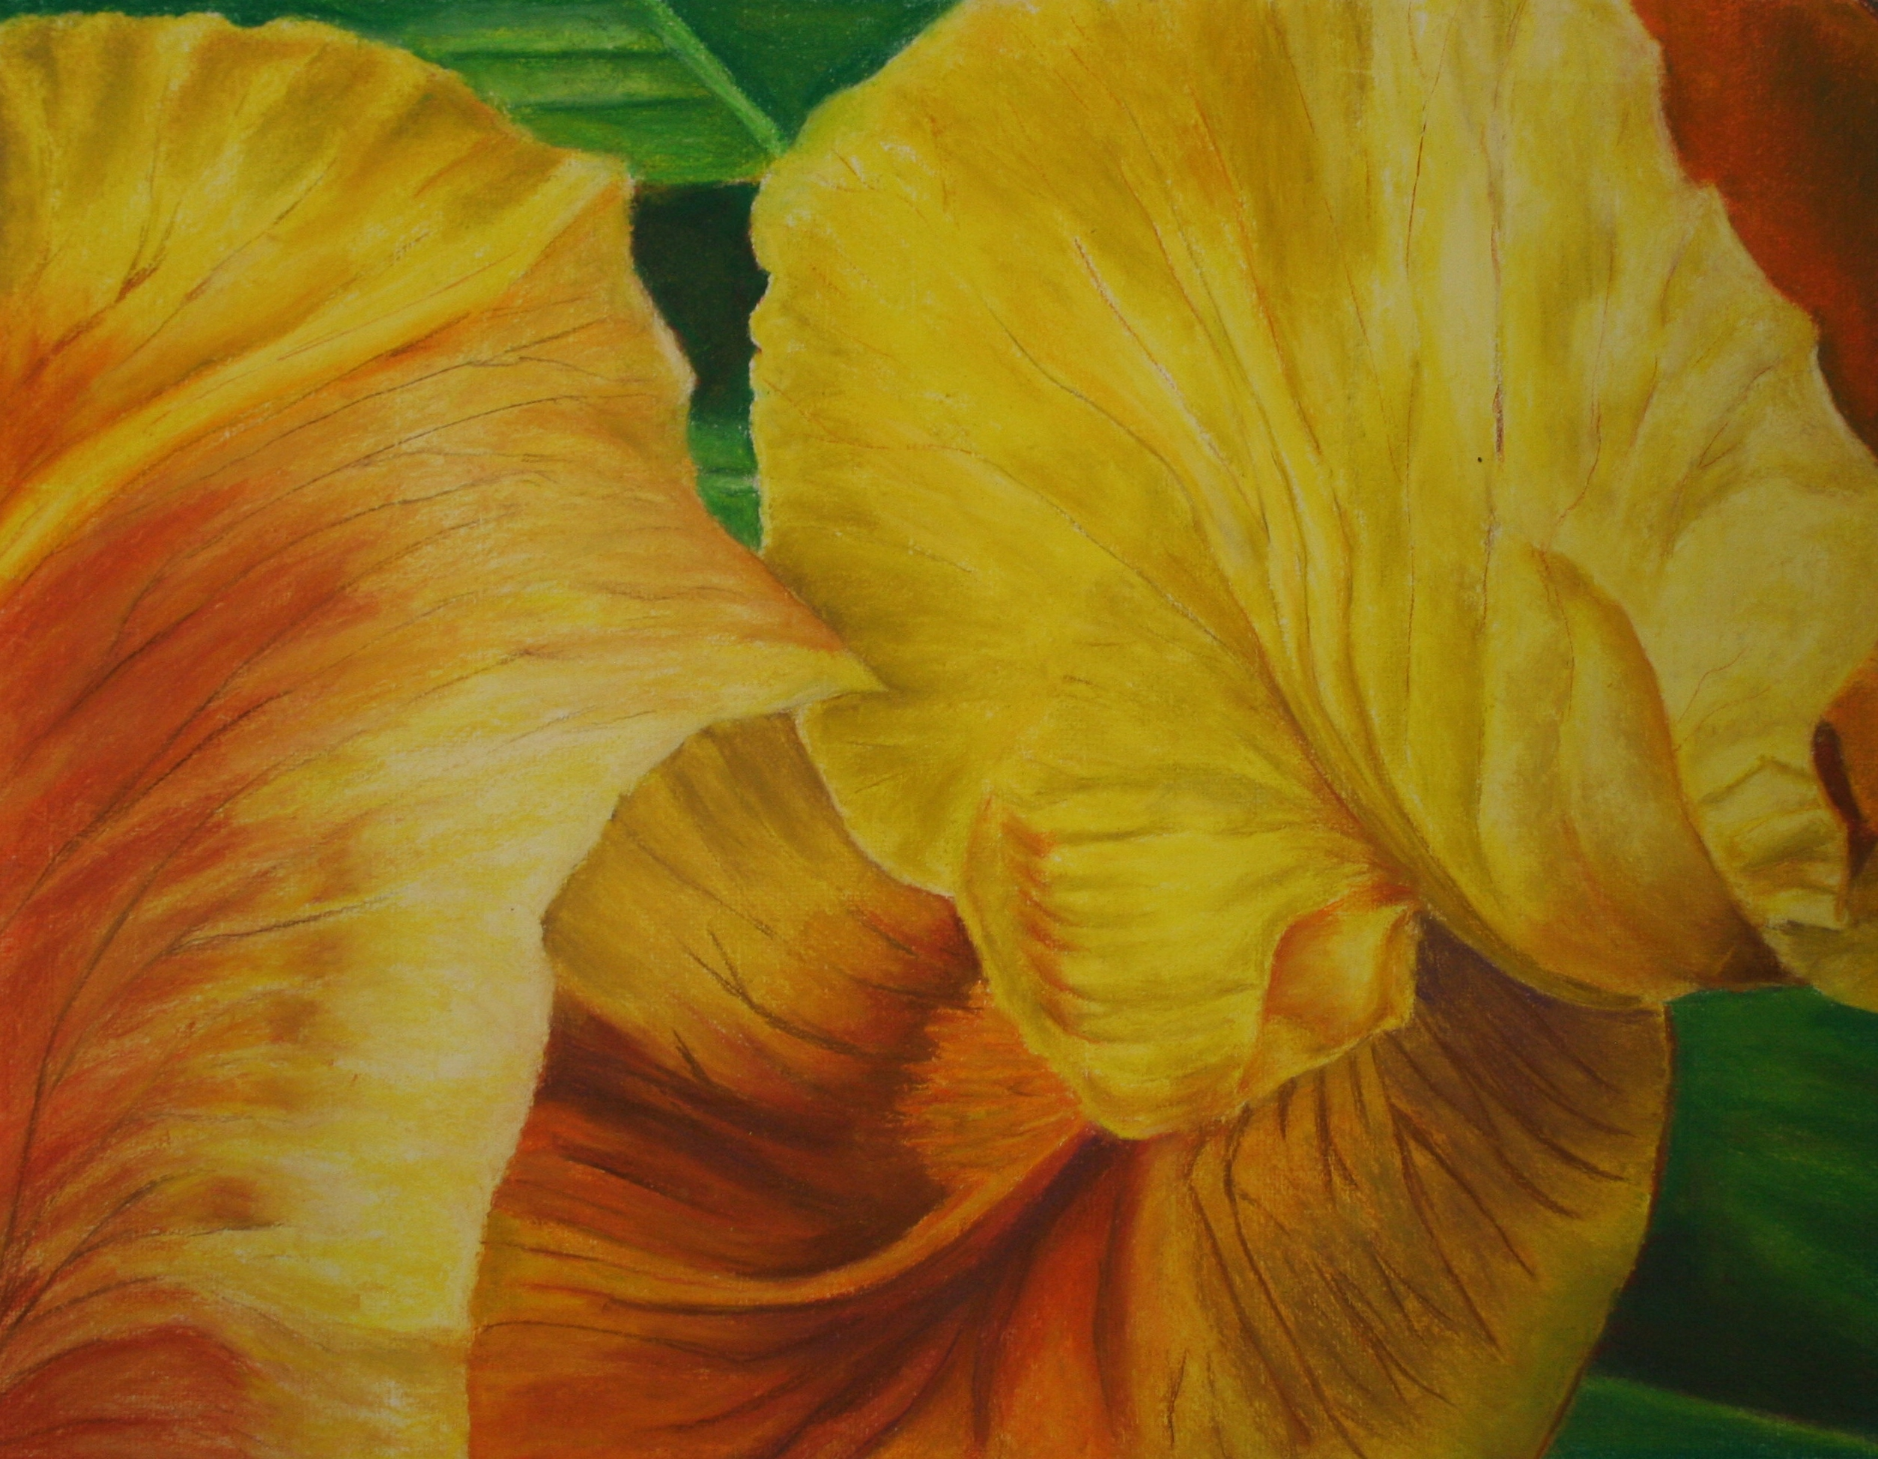

VISUAL ARTS HANDBOOK

Maria Gaspar
Visual Arts Mission Statement
Students participating in the Visual Arts will
develop skills and techniques to be creative thinkers
and innovative designers in a changing world.

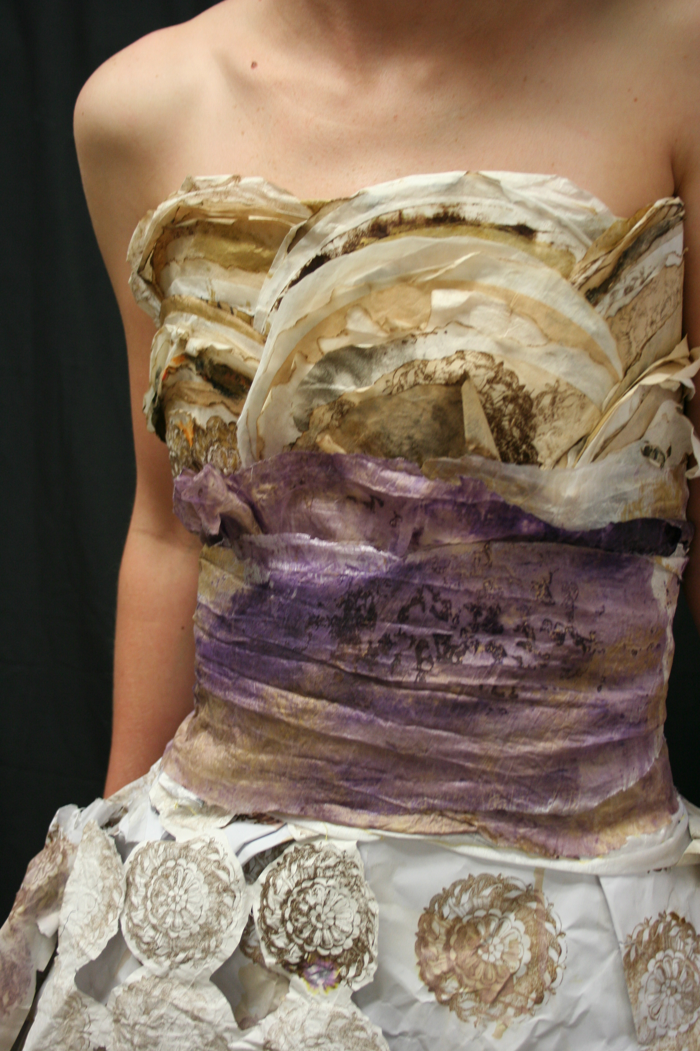

Dress by Alicia Wilby. Recycled coffee filters, stamped paper, onion skins, watercolor tissue.
Visual Arts Handbook

It is the goal of the Visual Arts Department to assist each student so that the student will:

- Have the opportunity to pursue and fulfill the requirements by the College Board for Advance Placement Studio Art credits.

- Use current technology

- Compete for Visual Arts’ scholarships

- Have an awareness of career opportunities and the appropriate advanced training, college or professional experience that is necessary to pursue a career in his or her medium

- Receive background training in a variety of media, tools and techniques and develop mastery of skills in his or her chosen medium

- Participate in community, state, and national arts events

- Make contributions to society as a professional artist and/or business person and practice art with high regard and respect

- Understand copyright laws, liability and the difference between plagiarism and appropriation

- Have an appreciation for art history and know how to critique a work of art

- Have an awareness of current styles, techniques, media and movements in the visual arts

Procedures and Guidelines:

All students are expected to have an open mind, a positive attitude and a willingness to learn.

Student will focus on using his or her time in the studio classroom for optimum learning and production.

All students are expected to follow the rules outlined in the Cypress Lake High School Student Code of Conduct.

All students are expected to arrive to class on time.

Class will end upon dismissal by the instructor provided each person has cleaned up after the studio session.

Passes must be recorded in the classroom log when the student leaves or enters the classroom while class is in session.

Students may not be in the art building for any reason without teacher permission and supervision.

Food, drinks, and gum will not be permitted in the classrooms. Students may carry bottled water into the classroom.

Students are expected to behave in a mature and dignified manner at art exhibitions, performances, and appearances by guest artists, on field trips, and at other Center events. Politeness and attentiveness are expected.

Designated materials required daily for class are pencils, erasers, and sketchbooks. Other supplies will be required as needed for individual projects.

Students are expected to conserve materials and to care for and respect equipment and furniture. The studio should be left clean and orderly. Tools, materials, and projects are to be returned and stored in the designated places.

Appropriate safety procedures will be followed for the safety of all students. Students are expected to show respect for fellow students and their work.

It is the student’s responsibility to make up missed class work. Projects turned in after the due date will not receive the full credit grade.

Materials and Supplies:

All visual arts students will acquire an extensive portfolio of their own artwork as they advance through the program. Most of this work will become their property and will be vital to the process of securing college or art school admission and possible scholarships. The students are encouraged to build a personal collection of supplies and materials. A suggested list of materials and supplies accompanies this document below. In addition to the students personal art supplies, the department would like to store other consumable and non-consumables such as matt board, illustration board, papers, canvas, paints, brushes, printing materials, computer inks and quality printing papers, clay, glazes, plaster, photographic materials, digital cameras, and more. Funds provided by the district allow us to plan a basic course of instruction. In an effort to maintain an outstanding visual arts program, we are asking for a contribution of $20.00 per student per semester in order to purchase the additional supplies and art materials. Please make your check payable to Cypress Lake High School Center for the Arts and write your son or daughter’s name on the check. Students are expected to be ecologically and economically responsible for the conservation of the supplies and equipment in the art studios.

If for any reason the student is unable to make a contribution or obtain the items on the list, the student’s grades will not be affected and the student will participate in the class assignments.

Suggested Materials List:

* A toolbox for storing and carrying supplies

* A sturdy portfolio for transporting and storing artwork

*A variety of drawing pencils (2B, HB, 6B, and Ebony)

*A quality set of colored pencils (Prismacolor, Spectracolor, Derwent, Faber-Castell, set of 24 or more)

*A sketchbook that feels great to work in

Each student should feel comfortable with a format of choice. Hard covers are recommended.

*A black micron type pen

This could be any thin black pen used for drawing and mark making.

*A few kneaded erasers

*A hand held pencil sharpener

*A variety of good quality acrylic/oil and watercolor brushes

*A zip/flash drive, 16 GB minimum

Reading, Research, Writing, and Critiques

Students will be required to read, write, and talk about art. They are encouraged to research ideas and find solutions to assigned projects by using computer technology, reference materials from the library, class critiques, student reports, field trips, practicing artist’s visitations, discussions, interviews, notes from a video or documentary, and other sources of information.

The visual arts department has been building an art resource center in the classroom. We have an impressive collection of art-related books and magazines as well as on-line computers in the classroom. Students have the opportunity to use the books and periodicals to help them with their project ideas and solutions to problems. It is important that the books and magazines are returned to the art library after they are used.

Sketchbooks and Journals

Students should expect to have sketchbook assignments often and to share them with the instructor for credit on assignments. Sketchbooks can be used for researching and recording ideas, storage of memory, thoughts and images, making connections between information and his or her own ideas, thoughts about an exhibit or a work of art, planning steps for executing an idea, and for documenting information as in a journal. The sketchbook could be used to practice techniques, drawing from real life, drawing from imagination, arranging ideas for compositions, writing poetry, working on personal drawings and studies. Students should have one or more sketchbooks and work in them often.

Critiquing

Art criticism is an important part of the learning and growth process. The students will be assigned written and oral critiques.

Through critiquing, the students will develop:

An appreciation of art history

An appreciation of a variety of art forms

The ability to recognize quality in works of art

The ability to discuss and describe the artwork of others as well as their own in an objective, constructive and intelligent way

The ability to make comparisons between famous works of art and art produced by less known artists including student art by discussing media, style, technique, and subject matter

Portfolios and Exhibitions:

Portfolios

Each student will be required to maintain a portfolio in preparation for semester evaluations, college and scholarship applications and competitions, job interviews, exhibits, senior shows, portfolio days, Advanced Placement classes. Upper level students will be required to develop a digital Portfolio stored on a personal flash drive and Google Drive.

Exhibitions

The students will have the opportunity to participate in a variety of art exhibitions and competitions. A calendar of scheduled events and exhibitions will be available. These events will include:
Center for the Arts Gallery shows
Designs and Dreams
The High School Florida State Fair Portfolio Scholarship Competition
Scholastic Art Awards
Pride and Patriotism
Annual Young Artists Awards Juried Art Show
Art Fest -Art Under 20 / Sidewalk Chalk
Florida Congressional Competition
Junior Duck Stamp State and National Competition
Keep Lee County Beautiful Calendar contest

All students are expected to participate in the production and presentation of the Center campus gallery shows. This will include entering original work, matting, framing, labeling, hanging, lighting, invitations, publicity, program design, and other aspects of organizing a show. (Addendum #1, Exhibiting Policy)

Requirements for the Cypress Lake High School Center for the Arts Certificate in the Visual Arts Program:

See Addendum #2 for The Visual Arts Program of Studies.

Status in the Program

An assessment on each student’s performance in the program will take place at the end of each semester if the student’s grade falls below a B-. This includes assessment in portfolio content, artistic development, and self-management skills. Students who are falling below expectations will be put on probation and issued a Contract for Improvement (See addendum #3)

Freshmen and Sophomore Expectations

If a student is not meeting expectations based on weekly performances and/or work inconsistencies, the student will be notified in advance of a date to meet with the faculty for a performance review. The students should be prepared with 7-12 quality works of art that exhibit the highest level of achievement up to date. The contents could include drawings, painting, collage, multi-media, printmaking, photography, digital, ceramics, sculpture and other art forms. The work may be class assignments or work produced outside of the classroom studio, appropriate for the assessment review.

Junior Expectations

Junior students will be assessed the first semester of their junior year. Art works should be uploaded to their Portfolios in Google Drive as art work is completed. Students will be notified in advance of a date to meet with the faculty for a performance review. The junior student should be preparing a portfolio and working towards the Advanced Placement exam that can be taken at the end of the junior or senior year. The student is expected to have 12-15 pieces of artwork that exhibit their highest level of achievement up to date.

If the junior art student is in good status standing during the first semester of their junior year, they will not need to be formally assessed second semester.

Senior Expectations

All seniors are expected to participate in the highest level of art classes including the Advanced Placement/Studio Art program. The student will prepare a body of work addressing three major concerns in the production of art: (1) a sense of quality in the student’s work; (2) the student’s concentration on a particular visual interest or problem; and (3) the student’s need for a wide range (breadth) of experience in formal, technical, and expressive content. The student will receive college credit if he or she passes the AP exam with an acceptable score.

Visual Art majors are expected to continue their art classes through their senior year. If a student does not have an art class during his or her senior year, they will not receive a Certificate of Completion or Participation in the Arts program.

Senior Scholarship Opportunities:

NFAA (National fine Arts Awards)
Arts for Life Scholarship (Columba Bush)
Florida State Fair fine Arts Senior Portfolio Scholarship
Scholastic Art and Writing Awards
Ft. Myers Beach Art Association
Southwest Florida Craft Guild
Florida South West University
FGCU Scholarship
Robert Rauschenberg Big Arts Scholarship

Senior Show

Seniors will be required to present a senior exhibition. Each senior is to prepare work that was done at the upper level (junior and senior years) to be displayed in a neat and orderly manner. Approval of the presentation and the selection of work for the senior show will be determined by the faculty at least 1 week in advance of the show. Each student will be required to sign an exhibiting contract.

Biographies must be proof read by a faculty member or administrator.

Framed senior biographies must accompany the work

(See addendum #4, Senior Show Expectation Contract)

Addendum #1

Exhibiting Policy:
The achievements of the Visual Arts Department at Cypress Lake High School Center for the Arts are largely measured by the outcome of two major visual arts gallery shows presented to the public, students’ families and friends, and school administration. We expect that all students in the department are capable of producing a number of quality works throughout the school year. It is important for all students to realize that their individual progress and product is vital to how the art department is judged.
All students are required to submit their best artwork into the judging for the two major campus gallery shows. We expect freshmen to submit at least one (1) quality piece per show. Sophomores or second year students are expected to enter at least two (2) quality works of art per show. Juniors are expected to submit at least three (3) quality works of art per show. Seniors are expected to submit at least four (4) quality works of art per show. The work submitted can be from classroom assignments, work done at home, or from outside workshops, self-generated, and in any medium or format.
Once the artwork is judged in to the show, it is the student’s responsibility to follow through with the process of getting the work ready to be presented. Pulling your work out after the judging is unacceptable. All students are expected to do whatever is necessary to turn it over to the hanging committee in a timely manner. The staff will be available to help with recommendations. Your quarter grades will be partially based on compliance with this policy. You will receive grade credit for having a piece judged into the show as well as attending and participating in job assignments for the production of the show. Each student will submit the following information to your instructor the Monday after each opening. Your grade will result in a 50% if you do not return this survey on the due date.

Name: ________________________________Grade: ___________

Title of Work | Judged In and Ready for  Display on  Time | Job Performed  To Best  Of Ability | Show Attendance
Criteria for grades  No of works submitted correct x  incorrect 0 | 100% | 100% | 100%

*Check mark (✓) next to the pieces that were judged in.
*Check mark (✓) next to the piece if paperwork was correct and on time.
*Check mark (✓) next to the piece if it the art was ready for display on time.
*What job were you assigned?
___________________________________________________
*Check mark (✓) after job description if you feel you performed to best of your ability.
*Were there any problems that occurred that prevented you from completing the job? Explain:

Addendum #2 Tracks of Study

Cypress Lake High School Center for the Arts provides the best possible arts education for students who would like to pursue a more concentrated study in the disciplines of Dance, Media, Music, Theatre, and Visual Arts. The Center stresses the development of the students’ individual and/or ensemble skills and talents to their fullest potential while fostering a lifelong appreciation of the arts. Expanded arts opportunities are offered for all students at Cypress Lake High School Center for the Arts. All disciplines have a major track and elective classes to accommodate many levels and interests in the arts.

MAJOR TRACK
Students must audition to be awarded major track status. Those students who are accepted will follow the specific major track of classes for their department. Students who complete the program will graduate with a total of 9.5 or more credits in the Arts. Students who are privileged to study in the major track must be committed to developing their talents and gaining the most experiences from the program. Students are expected to take Center art classes through their senior year in order to participate in the Senior Show. Majors at the Center for the Arts have access to performance opportunities, master classes, fieldtrips, conferences, and other enrichment opportunities that maintain a rigorous standard of learning in the arts.

1ST YEAR
0104340 Draw I (1)
0101340 3D Studio Art 2 (1)
0100330 Art History 1 (1)

2ND YEAR
0104350 Draw 11(1)
0101350 3D Studio Art 3 Honors (1)

3RD YEAR
0104360 Draw III (1)
0109310 Portfolio I Drawing Honors (1)

3RD & 4TH YEAR
0109320 Portfolio Development 2D Design Honors (1) or
0109330 Portfolio 3D Design Honors (1)
ADVANCED PLACEMENT COURSES for College Credit
These Courses require permission from the Art Department Faculty.
0104300 AP Studio Art/Draw (1)
0109350 AP Studio Art/2D Design (1)
0109355 AP Studio Art/2D Design Portfolio Innovation (1)
0109360 AP Studio Art/3D Design (1)

ELECTIVE CREDITS
One or more elective credits can be taken the 2nd, 3rd or 4th year to make a total of 9.5 credits or more by graduation from the following courses:
0103300 Computer Graphics (1)
0103310 Advanced Computer Graphics (1)
8201210 Digital Media / Multi-Media Foundations 1
As a Center for the Arts participant students have the privilege of taking an elective with another Center discipline
(Media, Dance, Theater, Chorus, Orchestra, Band) if they have room in their schedule.
Addendum #3 Date __________

CONTRACT FOR IMPROVEMENT (Probation)
Student Name________________________ Grade Level __________
Semester of “Probation” _______________ Review Date __________
Reasons for Probation
- Not working to expectations
- Major projects incomplete
- Homework incomplete
- Excessive absences
- Unprepared for class
- Needs to focus and stay on task
- Other

Conditions of “Probation”
- Students must receive two consecutive satisfactory assessments as per the
above arts content area.
- Student and/or parent must return completed “Contract for Improvement”
within 10 days of_____________________.
- Other___________________________________________________________
I am requesting an opportunity to correct the deficiencies that have led to my probationary status and my potential withdrawal as a Major or Minor at the Cypress Lake High School Center for the Arts. I understand that failure to meet the conditions of the “Contract for Improvement”, as outlined above, will result in my withdrawal as a Major or Minor in the Arts program at Cypress Lake High School Center for the Arts at the beginning of the semester following my probationary period.
Student Signature ____________________________________ Date___________
Parent Signature _____________________________________ Date___________
Department Head ____________________________________ Date___________
Principal/Designee Signature ___________________________ Date___________

Addendum #4

Senior Show Contract

This is your final show at Cypress Lake High School Center for the Arts. It is a requirement, as written in the Visual Arts student handbook, to successfully complete this assignment in order to acquire the Certificate of Completion.

Follow the steps listed below and sign this contract to accept the terms. Any unsigned contracts will withhold your space and negate your privilege to display your work in the Center for the Arts gallery, located at 6740 Panther Lane, Fort Myers, FL.

Follow each step carefully and pay attention to detail.

1) Lay out the body of work created over the past four years and select only the quality works to be displayed in your given space.
2) If any work needs to be touched up or cleaned this is the time to do so. (Craftsmanship, craftsmanship, craftsmanship)
3) Matt and frame all work. Paintings need to be framed with existing frames or slats provided by your instructor. You may need to secure your own frames or have them professionally made. All school frames must be returned.
4) Sculptures must be displayed on pedestals.
5) A biography needs to be typed and displayed on the wall with your work. Have one of the teachers proof read it.
6) Your space needs to be prepared and completed by 5:00 PM the day before the show opens. The faculty will preview, and be responsible for all subject matter to be on display in a public building.
7) Any deviation from the above terms will be submitted as a proposal in writing and will be reviewed by the faculty. Faculty have the authority to accept or deny all proposals.

I accept the Senior Show Contract Terms as specified in this document.
Printed Student’s name
Student Signature Date
Visual Arts Department Head Date
Assistant Principal Date

Addendum #5

Procedures and Expectations Contract

I have read and understand the procedures and expectations stated in the Visual Arts Department Handbook and agree to fulfill the requirements and obligations as a Visual Arts student at Cypress Lake High School Center for the Arts.

Please return the slip at the bottom of the page with both parent and student signatures to the Visual Art Department teachers at the beginning of the school year.

Thank you,
The Visual Arts Department

~~~~~~~~~~~~~~~~~~~~~~~~~~~~~~~~~~~~~~~~~~~~~~~~~~~~~~~~~~~~

Procedures and Expectations Contract
I have read and understand the procedures and expectations stated in the Visual Arts Department Handbook and agree to fulfill the requirements and obligations as a Visual Arts student at Cypress Lake High School Center for the Arts.

Printed Student’s name Grade Level
Student Signature Date
Parent Signature Date

